**Experiment 5**

Query:

CREATE DATABASE experiment5;

USE experiment5;

CREATE TABLE eDetails (

empNo INT NOT NULL,

empName VARCHAR(20),

dept VARCHAR(20),

salary INT(10) NOT NULL,

doj DATE NOT NULL,

branch VARCHAR(20)

);

INSERT INTO eDetails (empNo, empName, dept, salary, doj, branch)

VALUES ('101', 'Amit', 'Production', 45000, '2000-12-03' , 'Bangalore'),

('102', 'Amit', 'HR', 70000, '2002-03-07' , 'Bangalore'),

('103', 'Sunita', 'Management', 120000, '2001-11-01' , 'Mysore'),

('104', 'Sunita', 'IT', 67000, '2001-01-08' , 'Mysore'),

('105', 'Mahesh', 'Civil', 145000, '2003-02-09' , 'Mumbai');

**1. Display all the fields of employee table.**

SELECT dept

FROM eDetails;

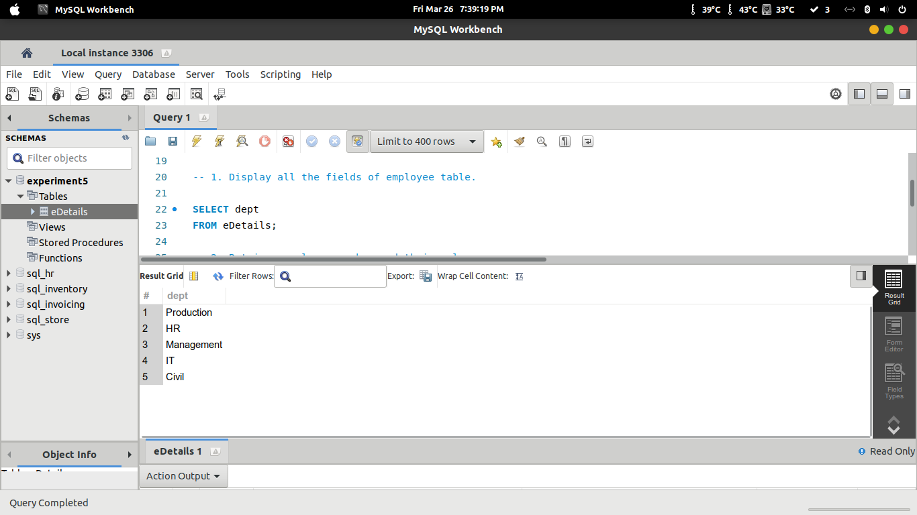

**2. Retrieve employee number and their salary.**

SELECT empNo, salary

FROM eDetails;

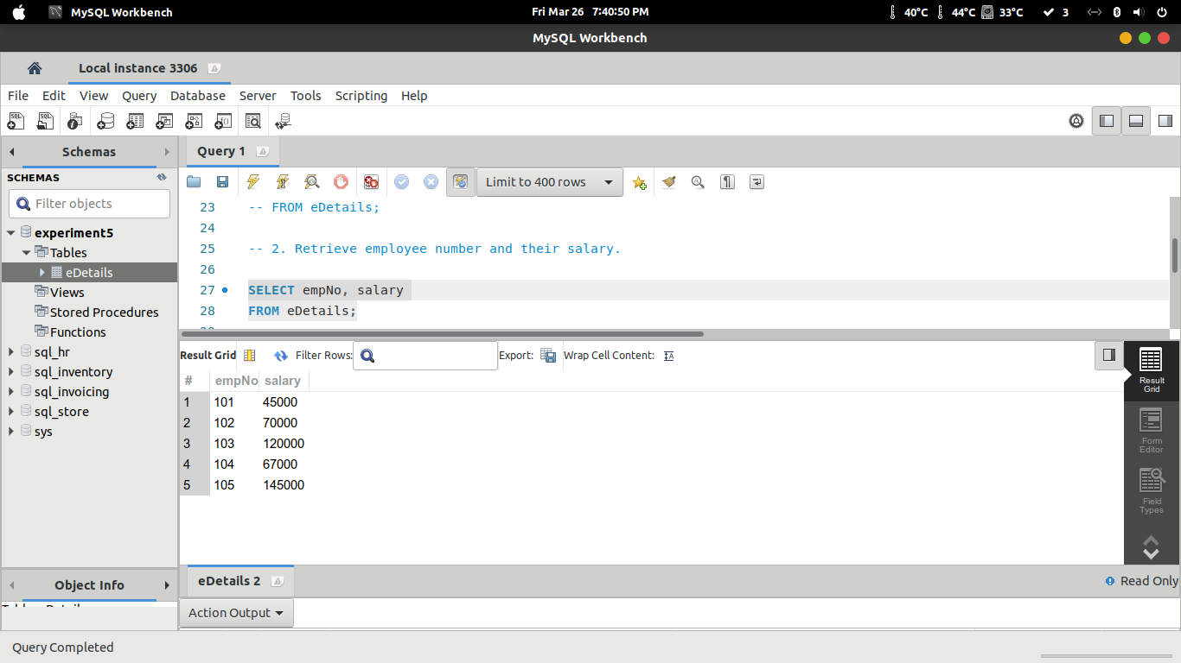

**3. Retrieve average salary of all the employee.**

SELECT AVG(salary), COUNT(*)

FROM eDetails;

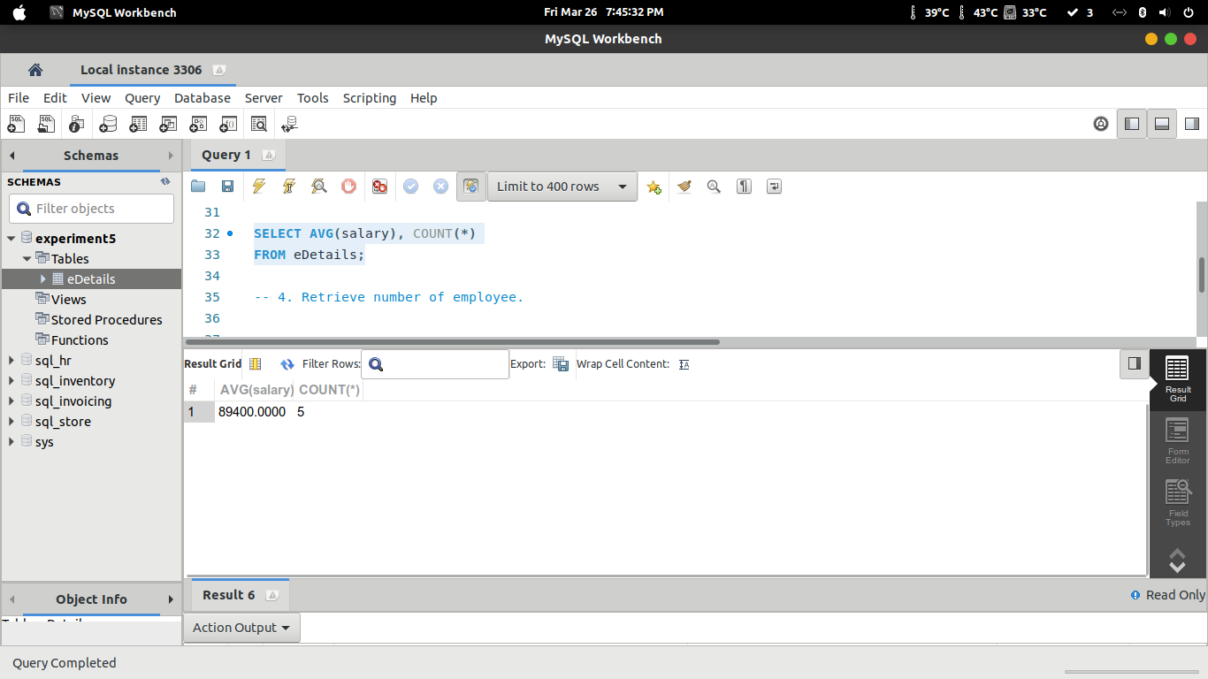

**4. Retrieve number of employee.**

SELECT COUNT(*)

FROM eDetails;

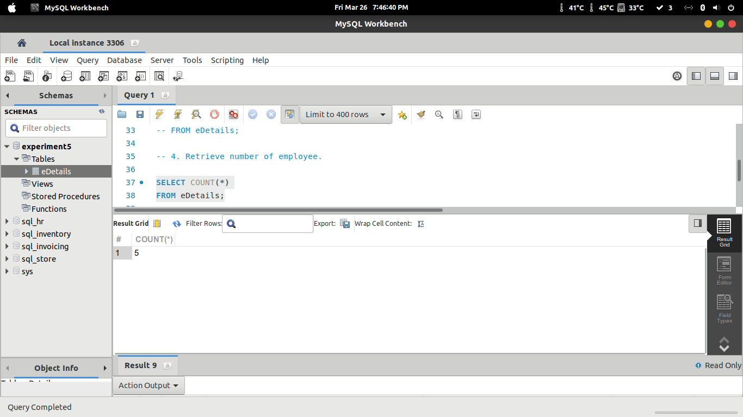

**5. Retrieve distinct number of employee.**

SELECT DISTINCT empName

FROM eDetails;

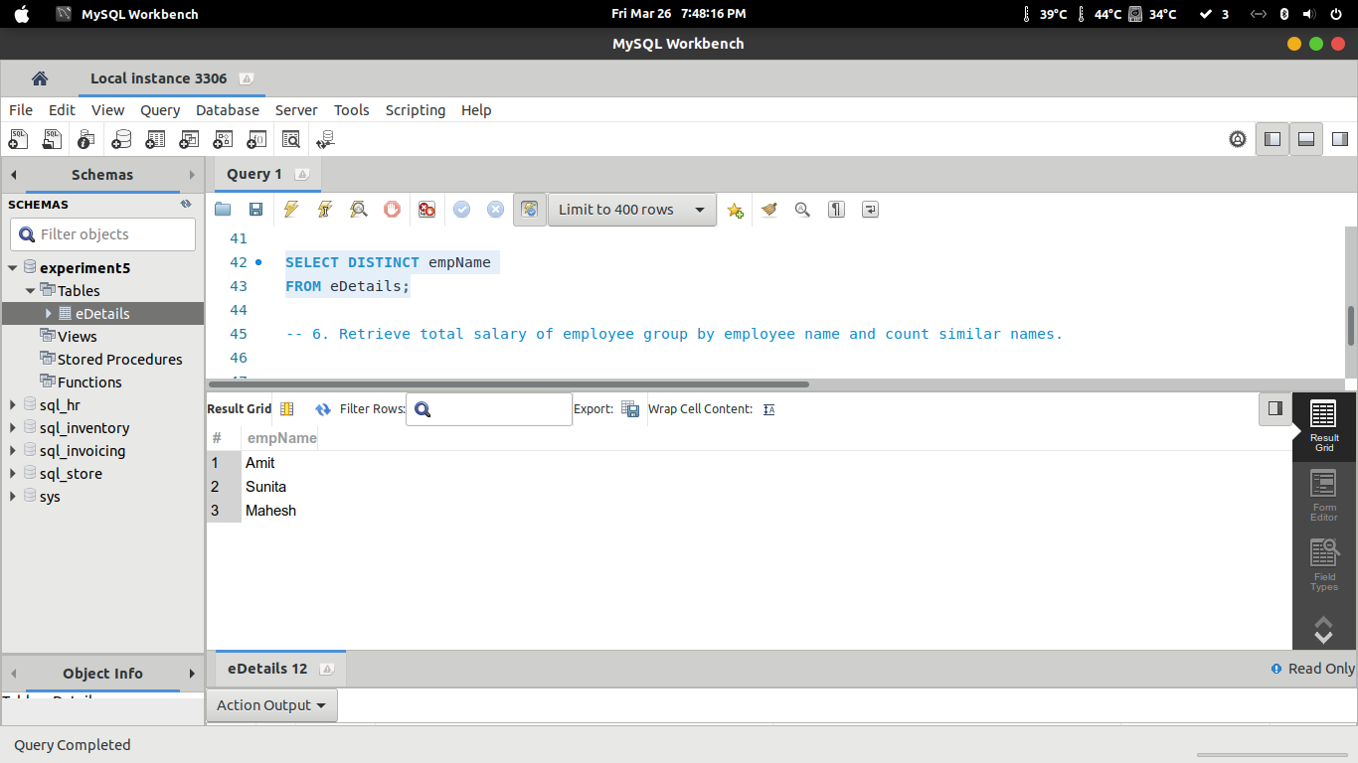

**6. Retrieve total salary of employee group by employee name and count similar names.**

SELECT *

FROM eDetails

ORDER BY empName, salary;

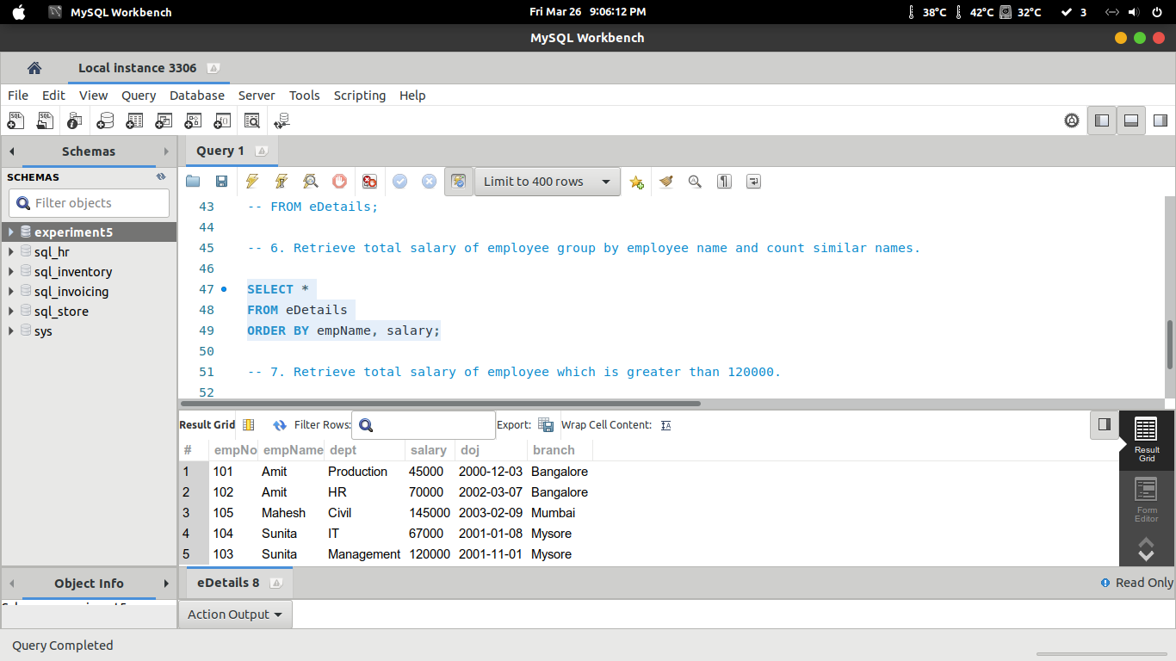

**7. Retrieve total salary of employee which is greater than 120000.**

SELECT *

FROM eDetails

WHERE salary > 120000

ORDER BY empName ;

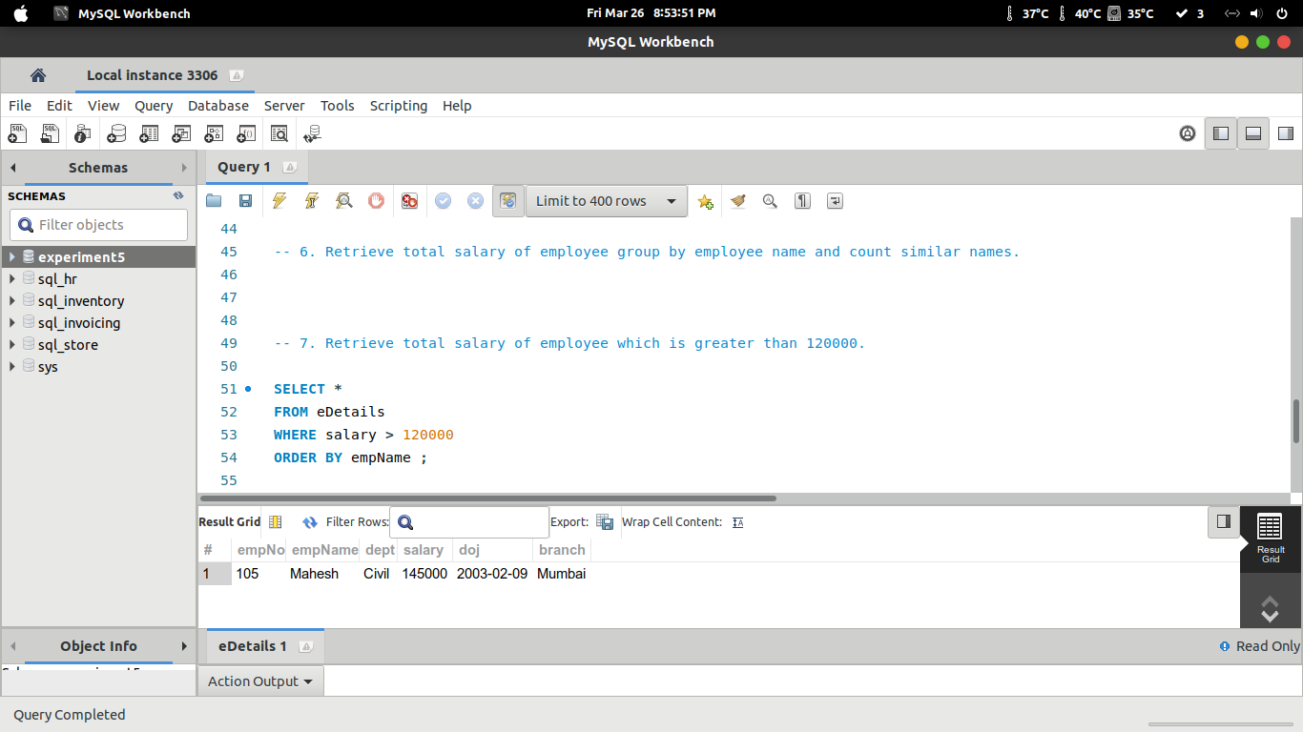

**8. Display name of employee in decending order.**

SELECT empName

FROM eDetails

ORDER BY empName DESC;

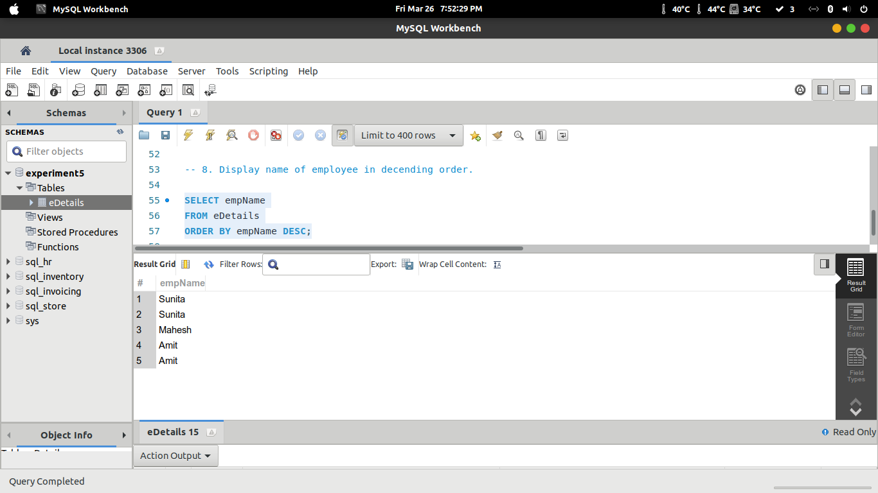

**9. Display the name of employee whose name is Amit and salary is greater than 50000.**

SELECT empNo, empName

FROM eDetails

WHERE empName LIKE 'A%' AND salary > 50000;

